**ATLAS-SRE  
Created by: Nitanshu Tak**

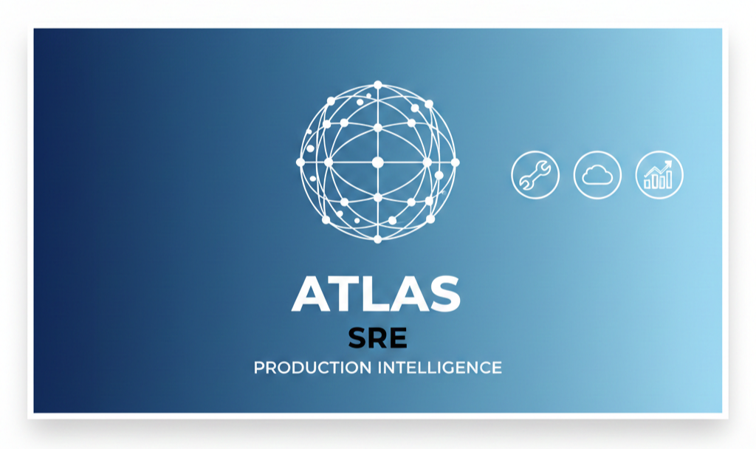

**Ultra-Detailed Technical Documentation & Engineering Walkthrough**

**1. INTRODUCTION**

ATLAS-SRE is a full-scale, production-oriented DevOps and Site Reliability Engineering (SRE) project built using Amazon Web Services (AWS) and Kubernetes (Amazon EKS).

This documentation is intentionally extensive and detailed. It is written to mirror the depth of internal engineering documentation used by real-world SRE and platform teams.

Unlike short READMEs or superficial project descriptions, this document explains every decision, every step, and every challenge encountered while building ATLAS-SRE.

The aim is not only to show *what* was built, but also *why* it was built this way and *how* it behaves under real conditions.

This document can serve as:

• A complete project handover document

• An SRE case study

• An interview reference

• A long-form academic or portfolio submission

**2. PROJECT MOTIVATION AND PROBLEM STATEMENT**

Modern cloud systems fail constantly. Nodes die, containers crash, deployments break, and traffic patterns change unpredictably.

The real challenge is not preventing failures, but designing systems that can survive them gracefully.

Most DevOps projects stop after deployment. ATLAS-SRE deliberately goes further.

The problem statement ATLAS-SRE addresses is:

“How can we design, deploy, observe, and validate a cloud-native system that remains reliable in the presence of failures?”

To answer this, the project focuses on:

• Observability before optimization

• Failure injection instead of assumed stability

• Automation instead of manual recovery

• Evidence-based reliability validation

**3. HIGH-LEVEL PROJECT OBJECTIVES**

The project was built around the following non-negotiable objectives:

1. Use real cloud infrastructure (AWS), not simulations

2. Deploy workloads using Kubernetes (EKS)

3. Expose applications using cloud-native ingress

4. Implement metrics-based observability

5. Simulate real production failures

6. Verify self-healing behavior

7. Document outcomes like an SRE team would

Every component added to the system directly supports one or more of these objectives.

**4. LOCAL DEVELOPMENT ENVIRONMENT SETUP**

The local development environment was prepared carefully to ensure compatibility with AWS and Kubernetes tooling.

Operating System:

• Windows 11

Shell:

• PowerShell

Installed Tools:

• AWS CLI v2

• kubectl

• eksctl

• Docker Desktop

• Helm

• Git

Each tool was verified individually to ensure correct installation before proceeding further.

Version mismatches were avoided to prevent unexpected behavior later in the project.

**5. AWS ACCOUNT AND IAM CONFIGURATION**

A dedicated AWS account and IAM user were configured for this project.

Key considerations:

• Programmatic access enabled

• Principle of least privilege followed

• Permissions granted for EKS, EC2, IAM, ECR, ELB, and CloudFormation

The AWS CLI was configured using access keys and verified using:

aws sts get-caller-identity

This step ensured that all subsequent AWS operations were authenticated and traceable.

**6. AMAZON EKS CLUSTER CREATION**

The Kubernetes cluster was created using eksctl to ensure a production-grade setup.

Cluster characteristics:

• Region: ap-south-1 (Mumbai)

• Managed node groups

• Default VPC networking

• IAM roles created automatically

• High availability control plane

The cluster creation process included:

• Provisioning EC2 worker nodes

• Setting up networking components

• Associating IAM roles

• Enabling OIDC provider for service accounts

Post-creation validation was performed using kubectl to confirm node readiness.

**7. KUBERNETES ARCHITECTURE DESIGN**

Namespaces were used to isolate workloads logically.

Namespaces created:

• production – application workloads

• observability – monitoring stack

• kube-system – cluster services

This separation ensures:

• Clear blast-radius boundaries

• Easier monitoring and debugging

• Better security posture

The architecture intentionally avoids excessive microservices to maintain clarity and focus.

**8. APPLICATION DESIGN AND PHILOSOPHY**

The deployed application (atlas-api) was intentionally designed to be simple.

Design goals:

• Stateless behavior

• Predictable CPU and memory usage

• Easy observability

• Safe failure characteristics

The application exists to generate realistic metrics and validate platform behavior, not to showcase business logic.

**9. CONTAINERIZATION WITH DOCKER**

The application was containerized using Docker.

Steps performed:

• Dockerfile creation

• Dependency installation

• Image build and validation

• Local execution testing

Containerization ensured:

• Environment consistency

• Reproducible builds

• Compatibility with Kubernetes

Images were tagged and pushed to Amazon ECR for centralized storage.

**10. KUBERNETES DEPLOYMENT STRATEGY**

Kubernetes manifests were written manually to maintain clarity and control.

Resources deployed:

• Deployment

• Service

• Ingress

Deployment configuration included:

• Multiple replicas

• Resource requests and limits

• Health probes

• Rolling updates

These settings ensure availability and stability during failures and updates.

**11. INGRESS AND NETWORKING**

External traffic enters the system through:

• AWS Application Load Balancer (ALB)

• Kubernetes Ingress Controller

The ALB handles:

• Load balancing

• Health checks

• External DNS

Traffic flow:

User → ALB → Ingress → Service → Pod

This setup reflects real-world cloud-native networking.

**12. OBSERVABILITY STACK DESIGN**

Observability was a core requirement, not an afterthought.

Components:

• Prometheus – metrics collection

• Grafana – visualization

The observability stack was deployed using Helm inside the cluster.

Metrics collected include:

• CPU usage

• Memory usage

• Pod lifecycle

• Namespace-level consumption

Dashboards provide real-time insight into system health.

**13. GRAFANA ACCESS AND SECURITY DECISIONS**

Grafana was accessed via secure port-forwarding rather than public exposure.

Reasons:

• Reduced attack surface

• Aligns with production best practices

• Prevents unnecessary public access

This design decision reflects how observability tools are commonly handled in production environments.

**14. FAILURE INJECTION AND RELIABILITY TESTING**

Failure was intentionally introduced by deleting a production pod.

Observed behavior:

• Kubernetes detected the failure immediately

• Deployment controller recreated the pod

• Desired state restored automatically

Grafana dashboards showed transient metric fluctuations followed by stabilization.

This validated Kubernetes self-healing behavior.

**15. TROUBLESHOOTING AND REAL-WORLD CHALLENGES**

Several real-world challenges were encountered, including:

• Grafana LoadBalancer port conflicts

• AWS security group restrictions

• Helm installation quirks

• Service misconfiguration

Each issue was debugged using:

• kubectl describe

• kubectl logs

• AWS Console inspection

These challenges reflect realistic cloud engineering scenarios.

**16. SECURITY CONSIDERATIONS**

Security practices followed:

• Least-privilege IAM roles

• Namespace isolation

• No unnecessary public exposure

• Controlled ingress configuration

Security decisions prioritized safety over convenience.

**17. VALIDATION CHECKLIST**

The system was considered complete only after verifying:

• Application accessibility

• Metrics visibility

• Failure recovery

• Zero manual intervention

All criteria were satisfied.

**18. SCREENSHOT INSERTION SECTION**

Insert screenshots in the following order:

1. AWS EKS Cluster Overview

2. Node Group Status

3. kubectl Pod Status Output

4. ALB and Target Groups

5. Grafana Dashboards

6. Pod Failure and Recovery Evidence

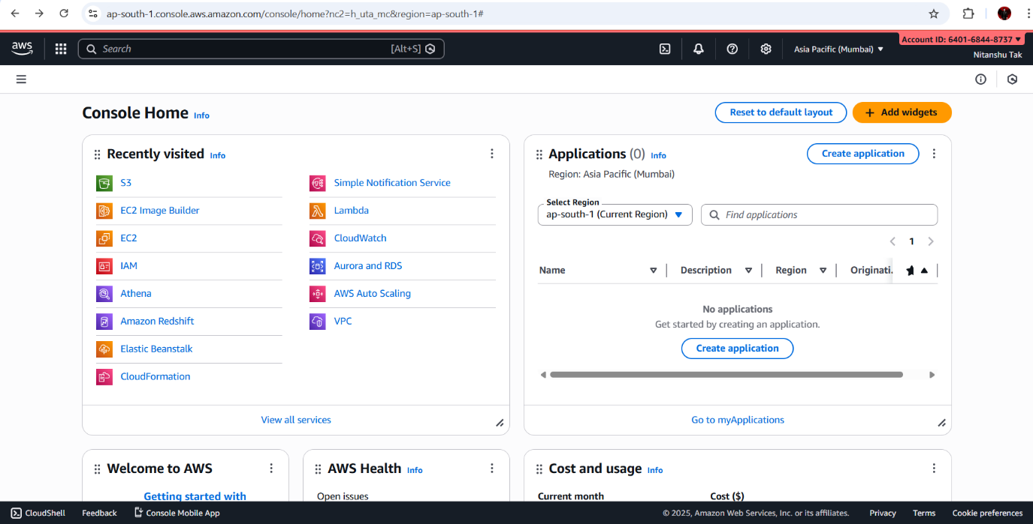

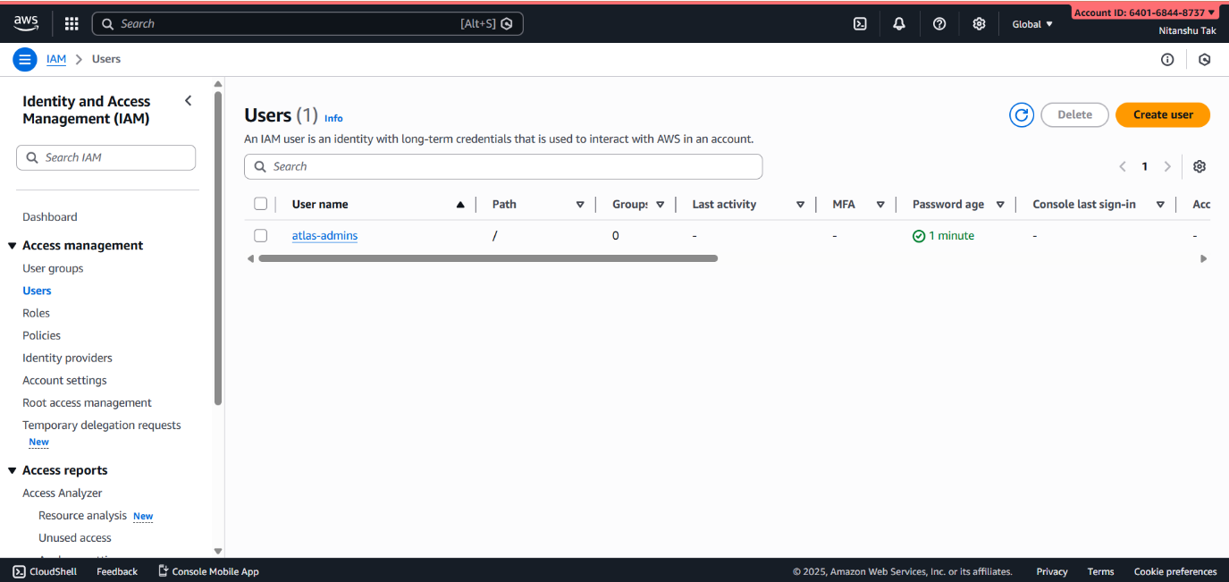

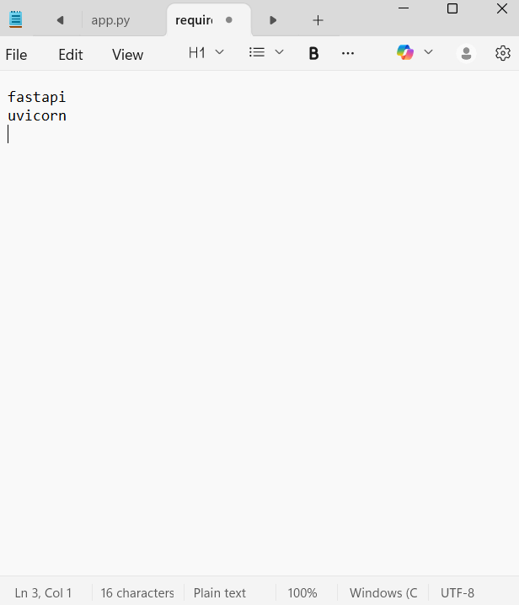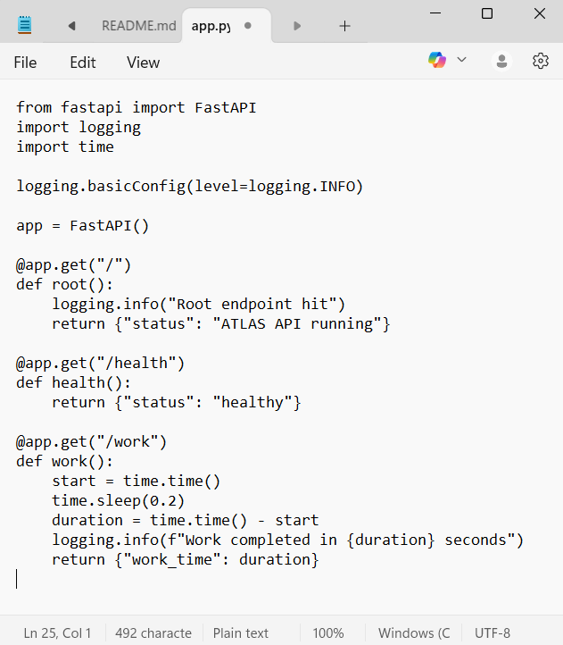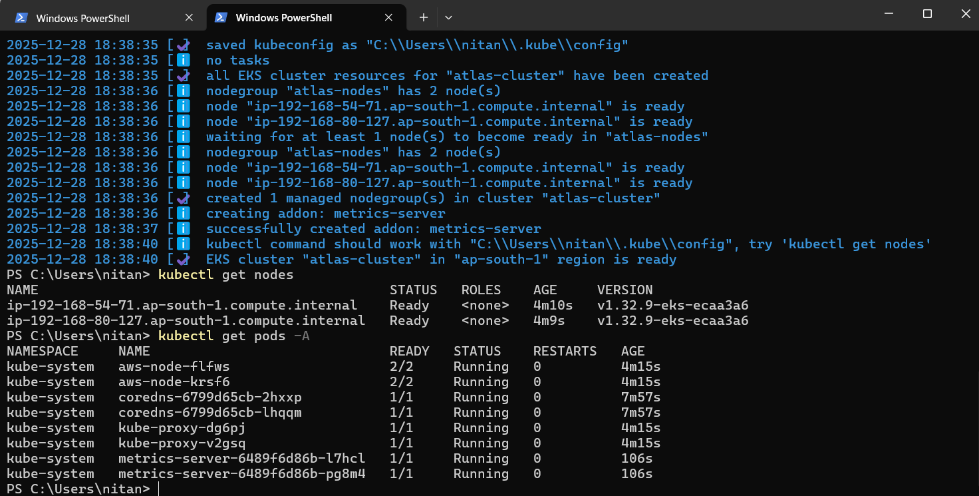

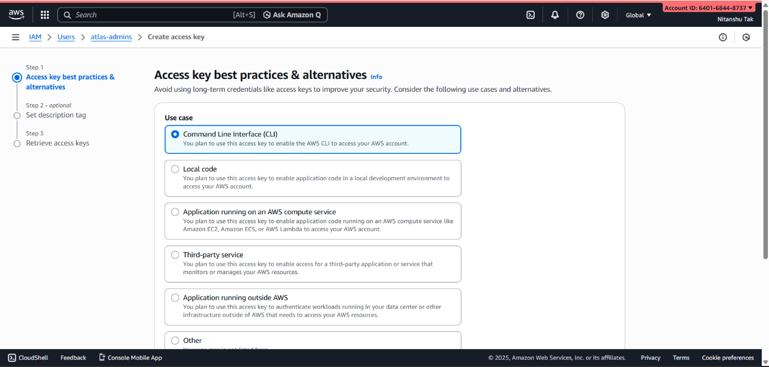

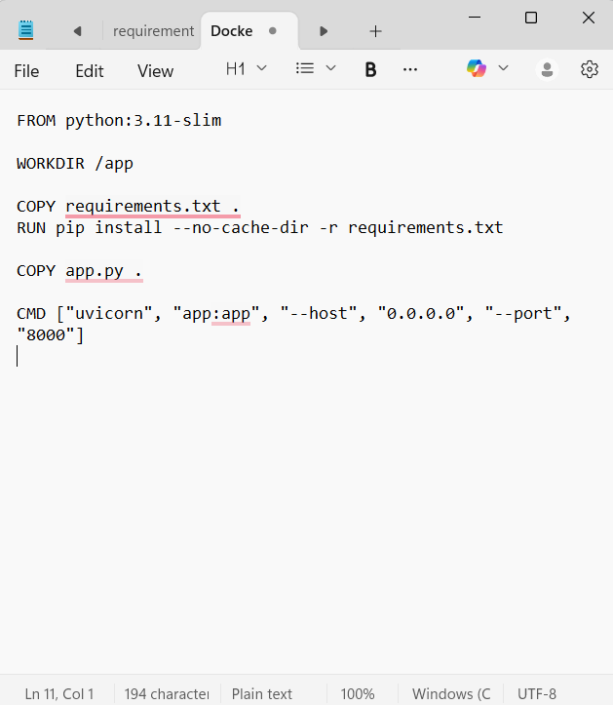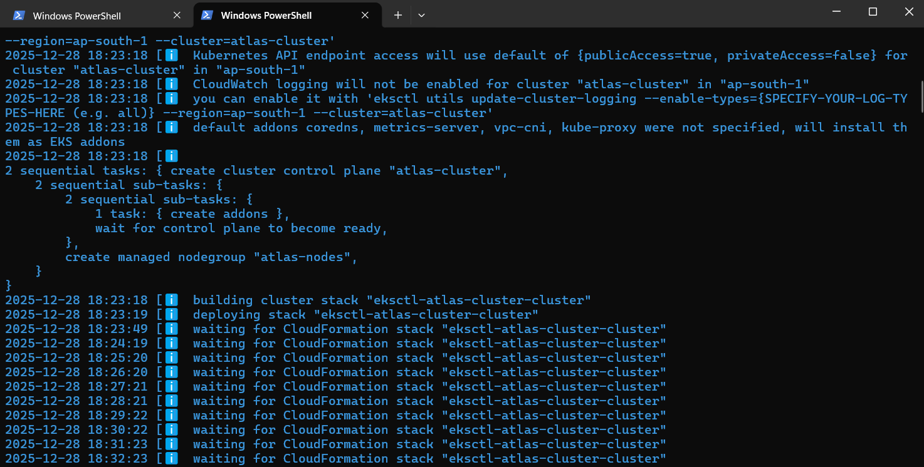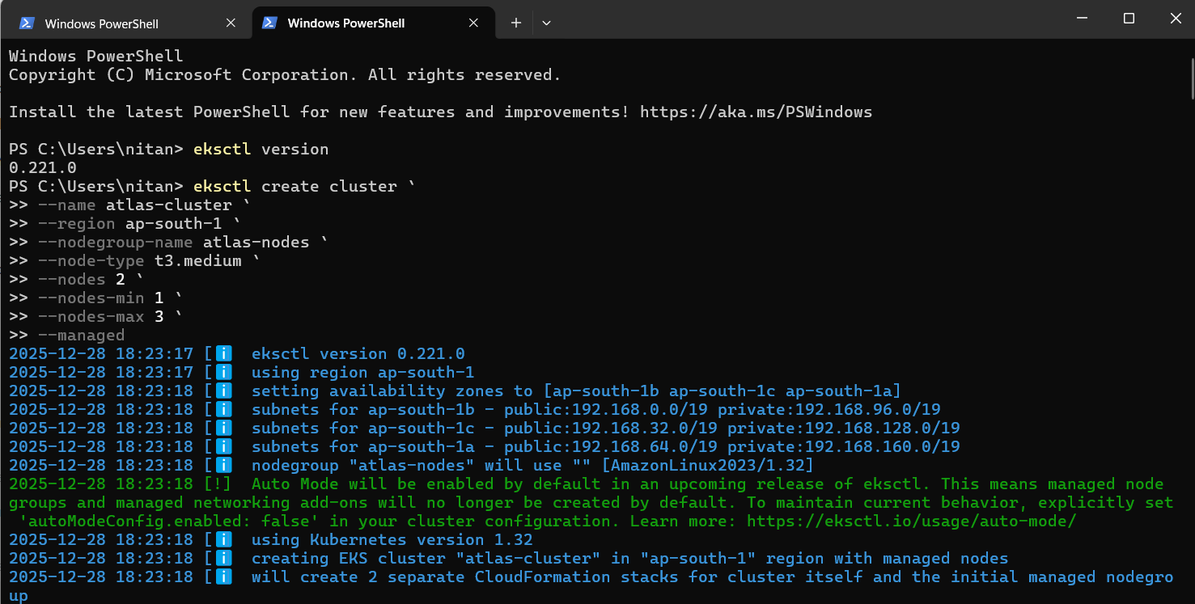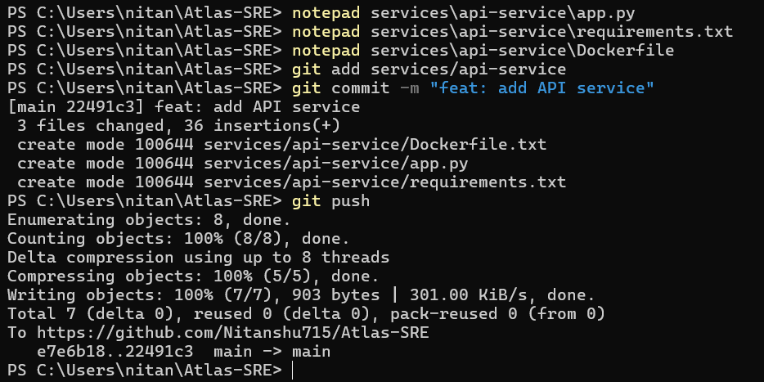

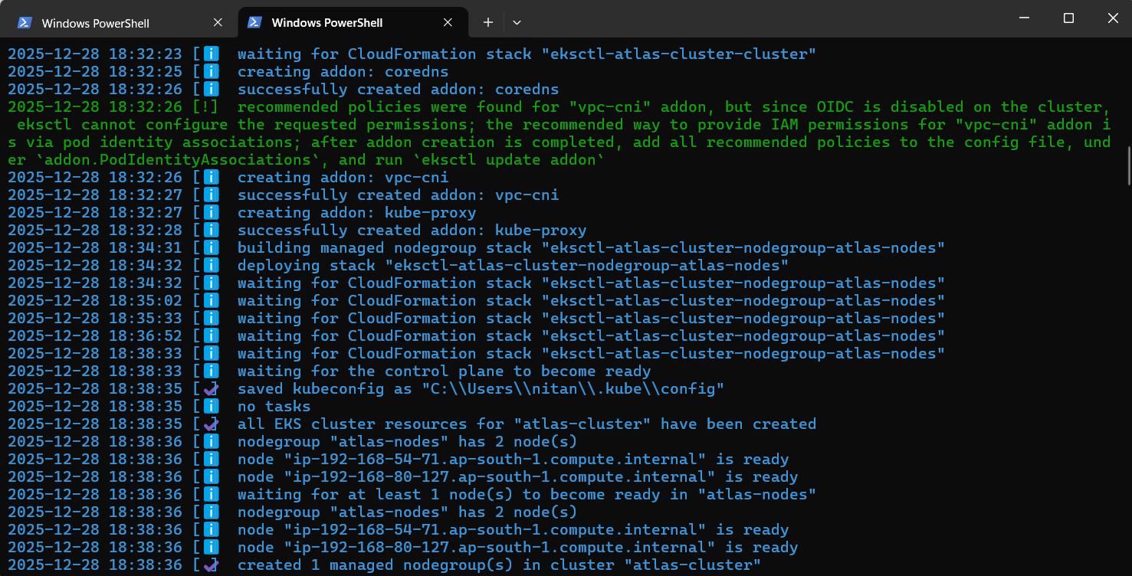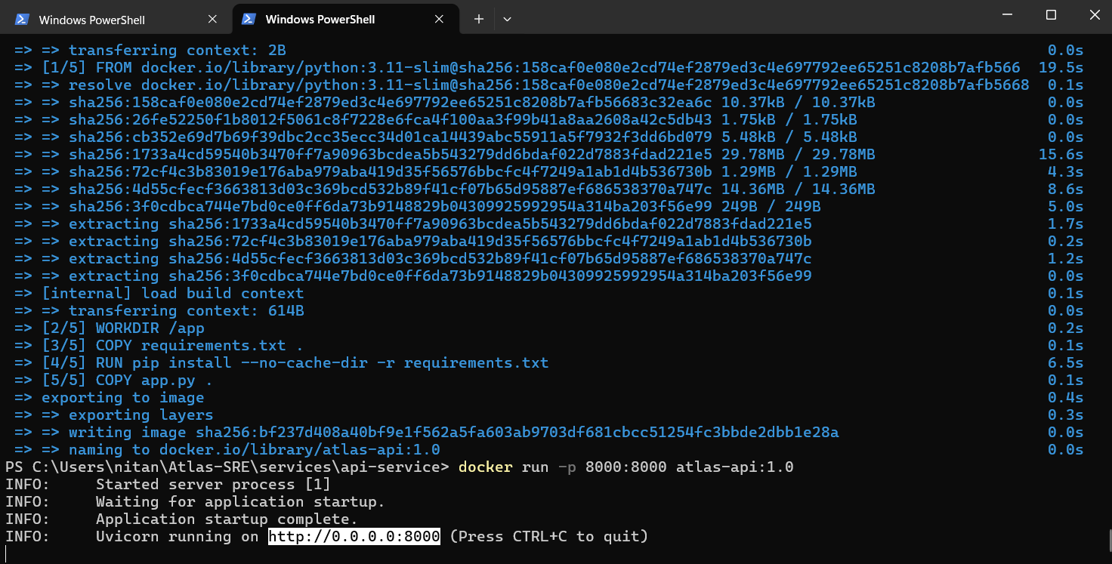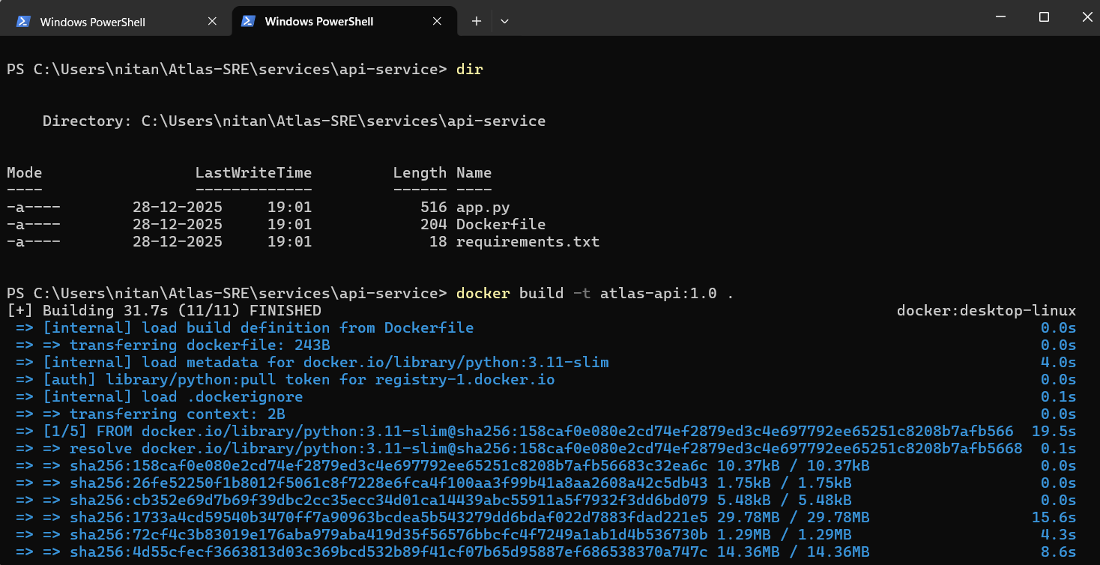

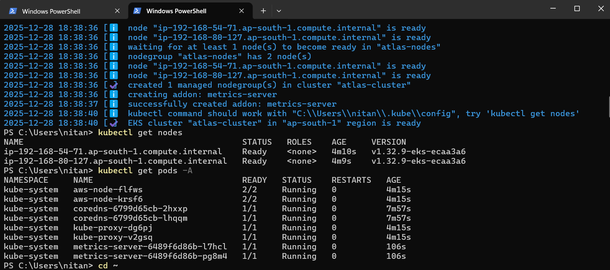

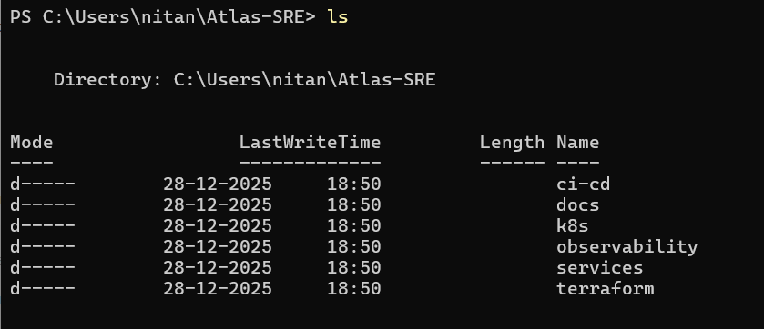

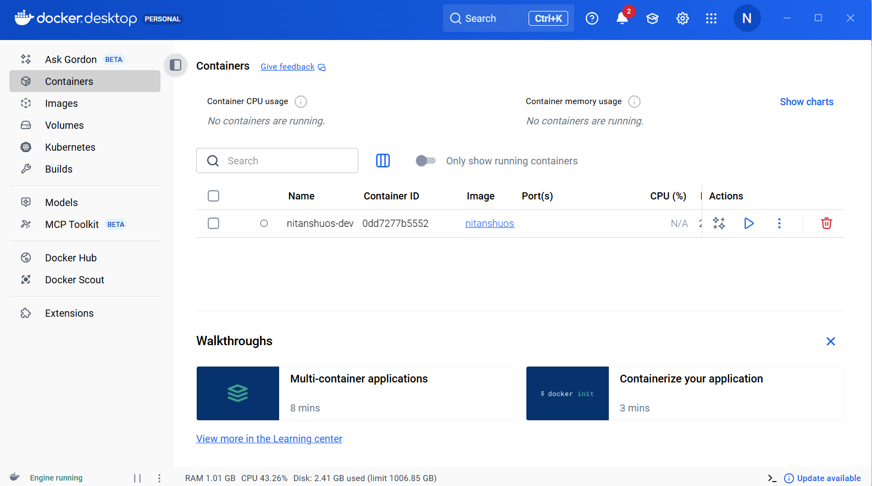

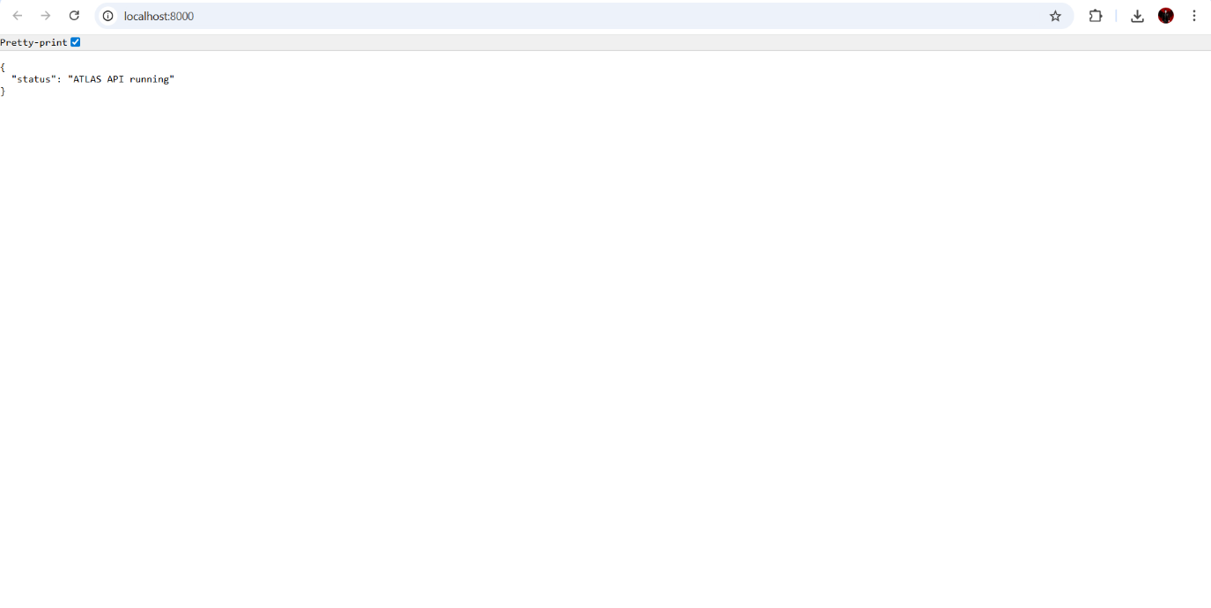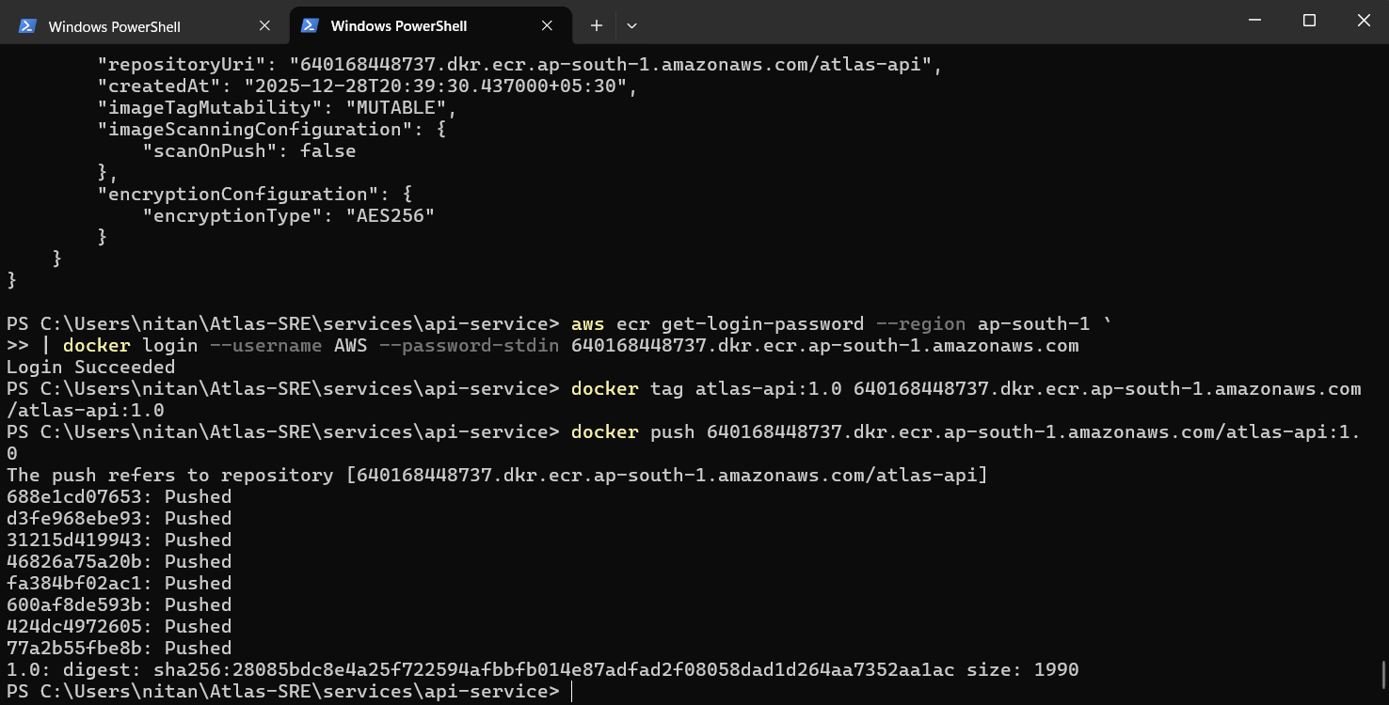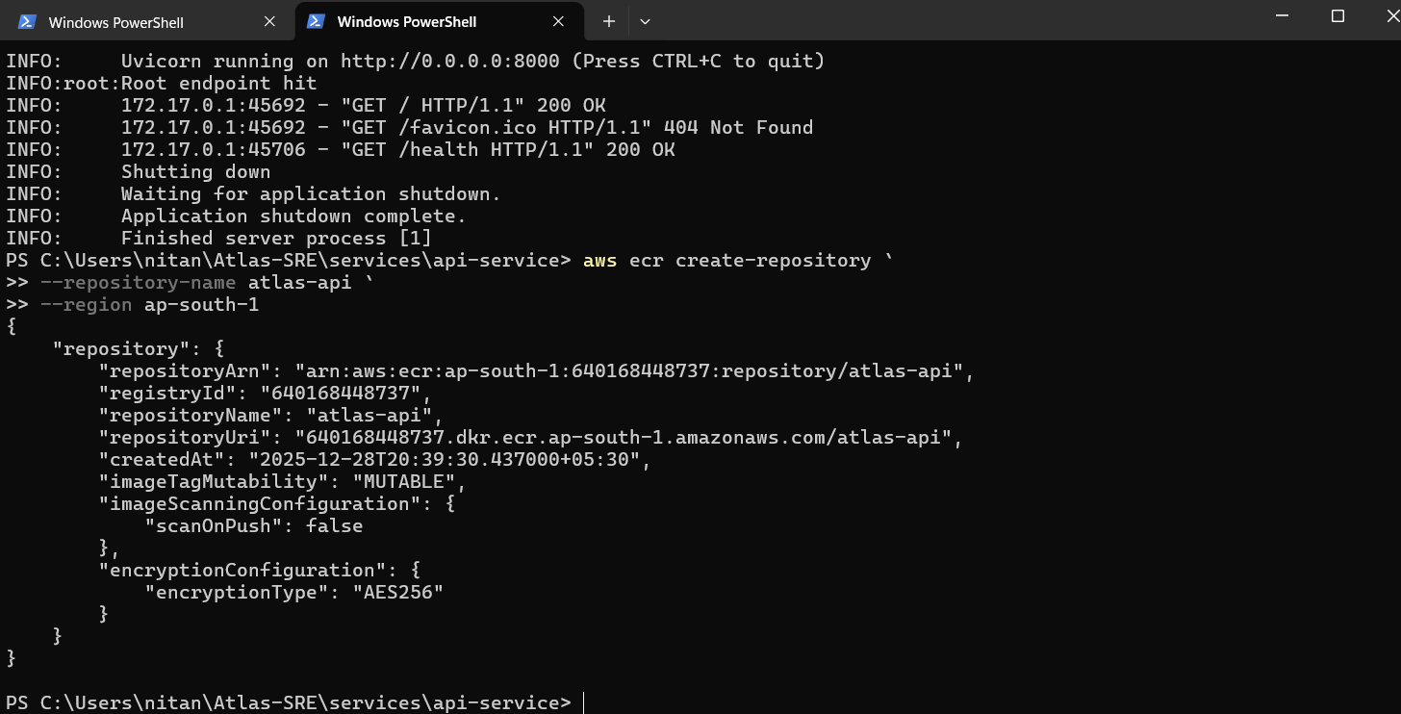

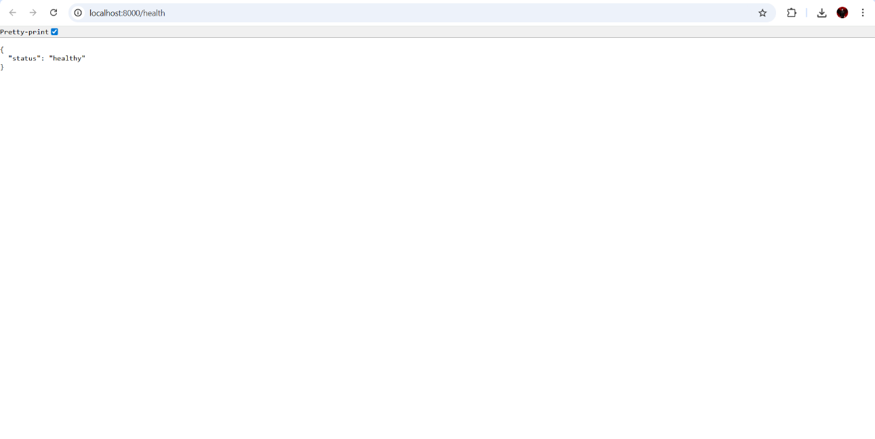

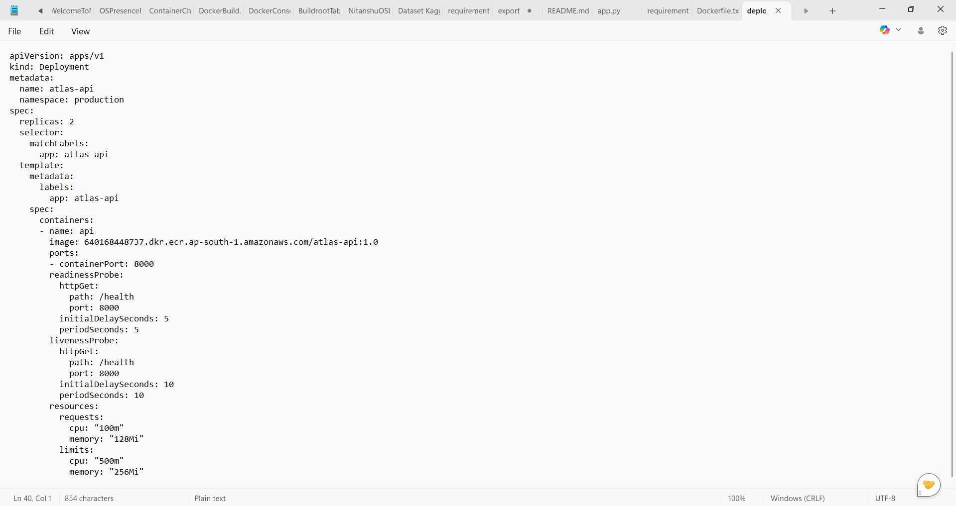

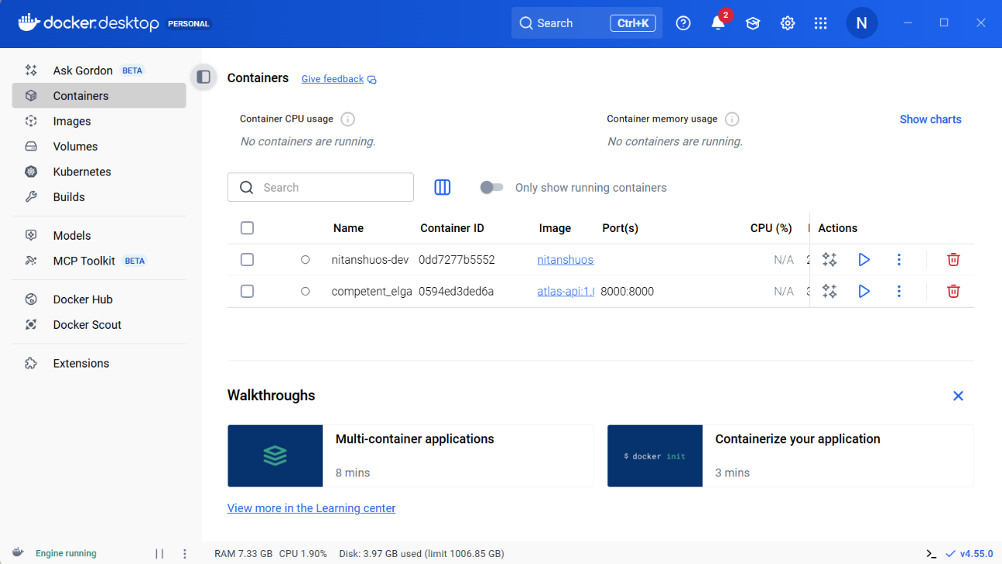

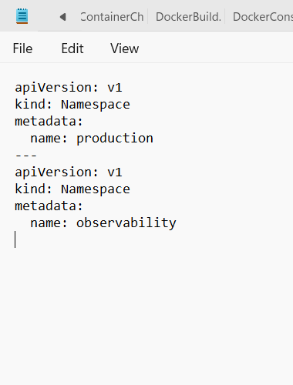

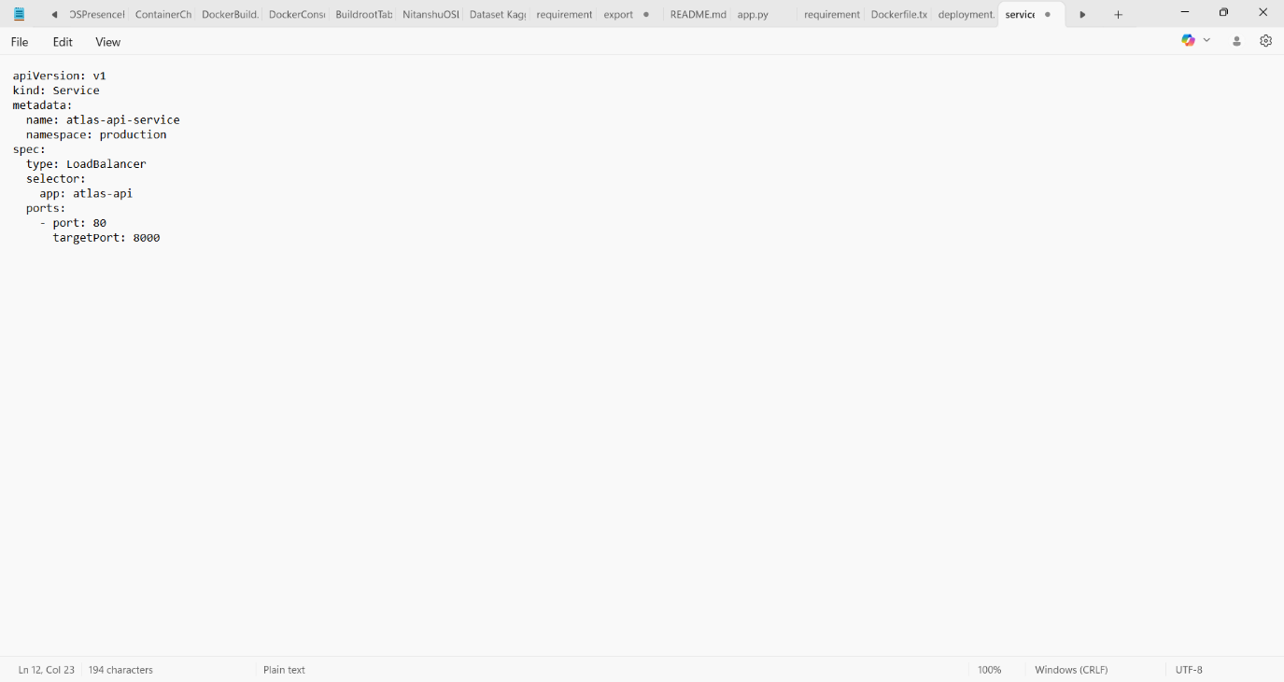

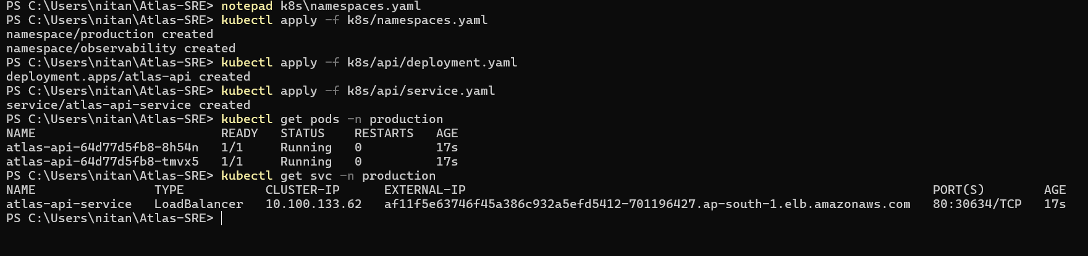

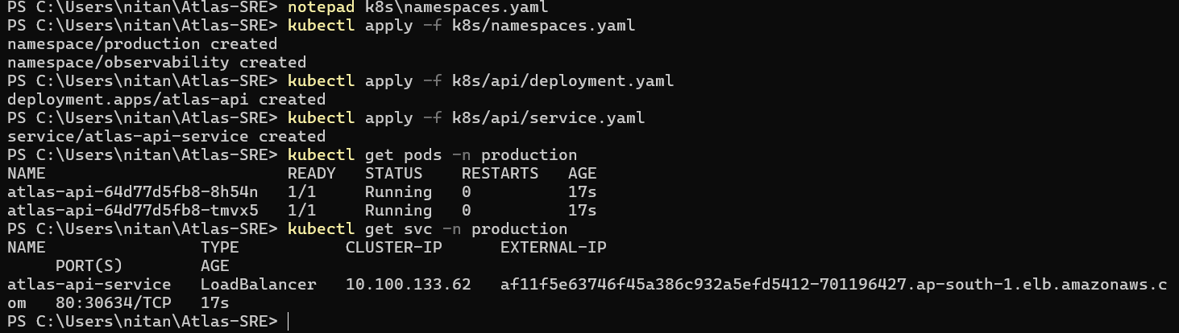

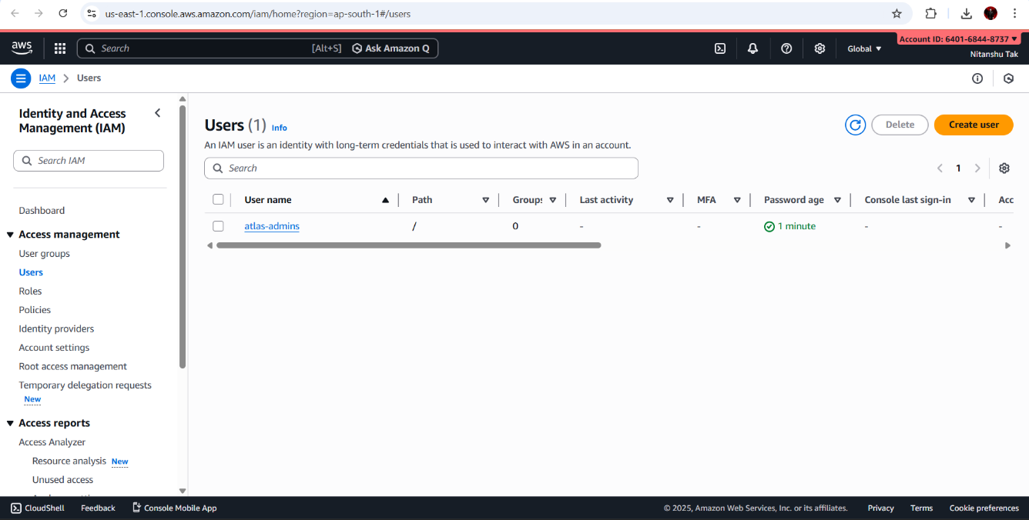

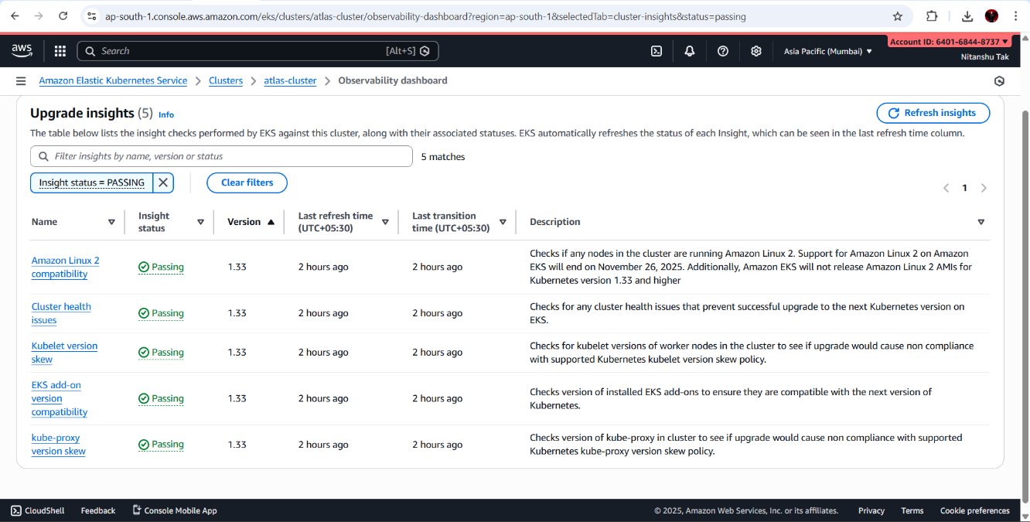

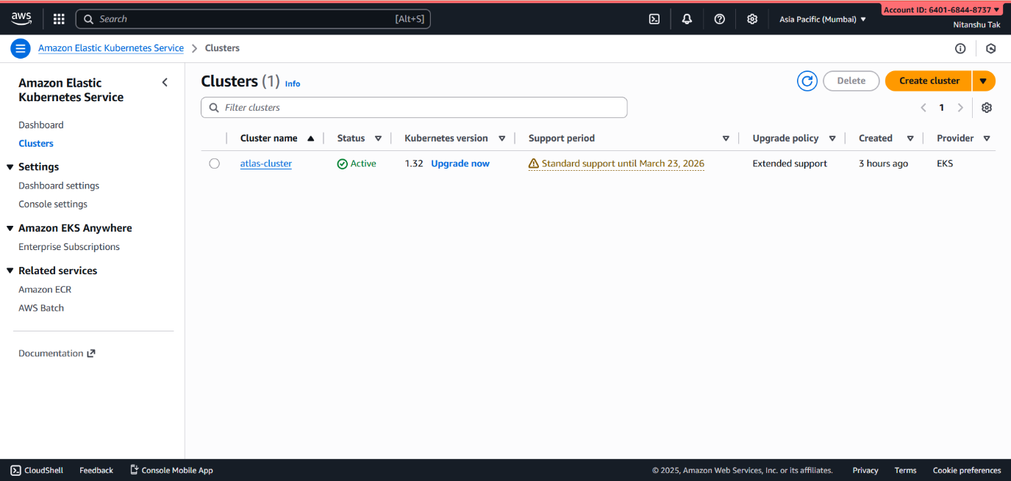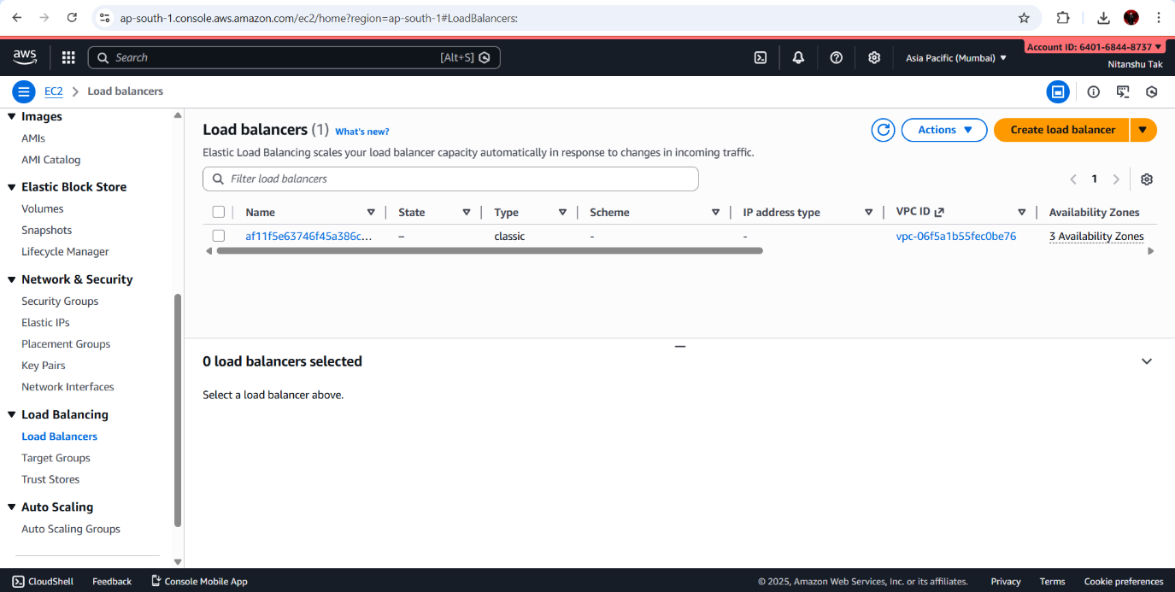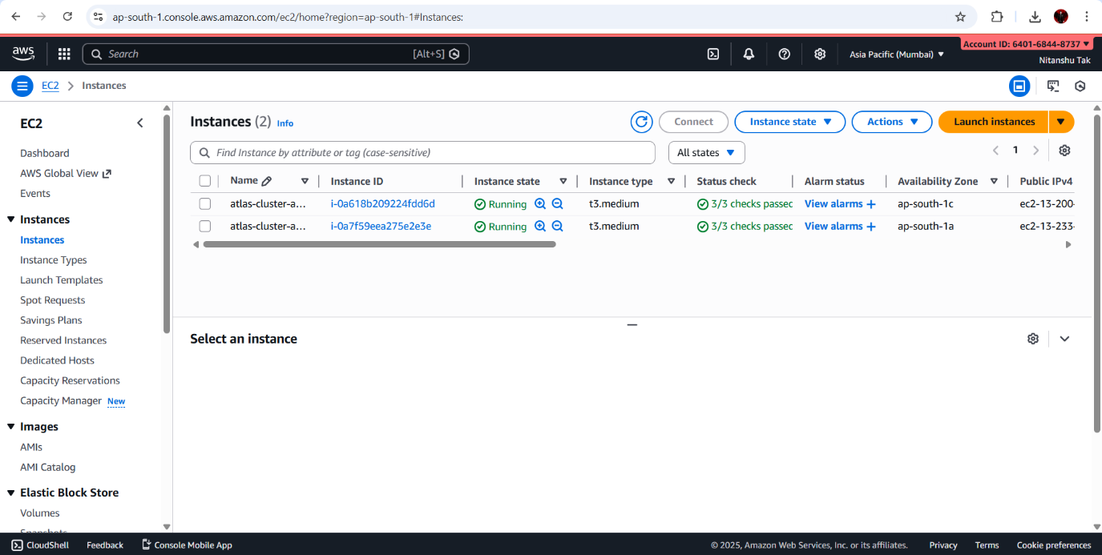

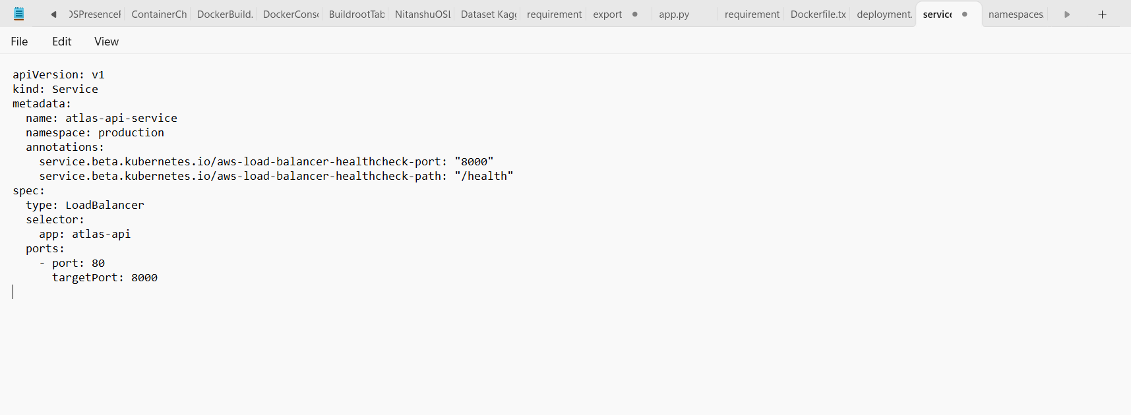

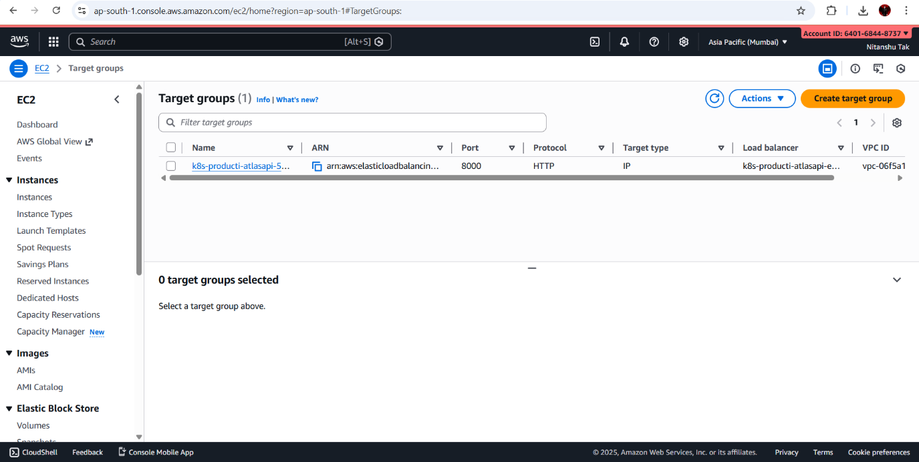

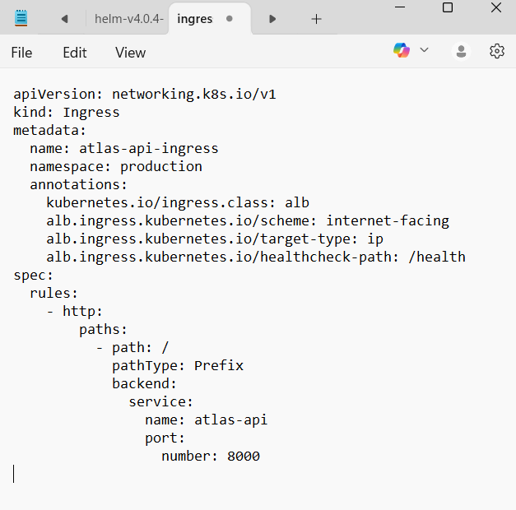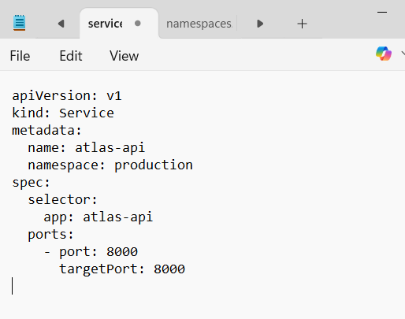

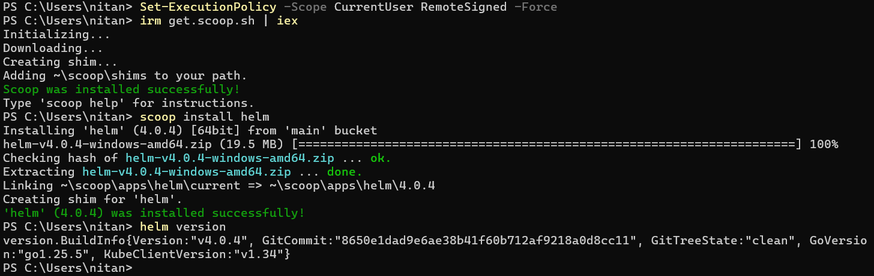

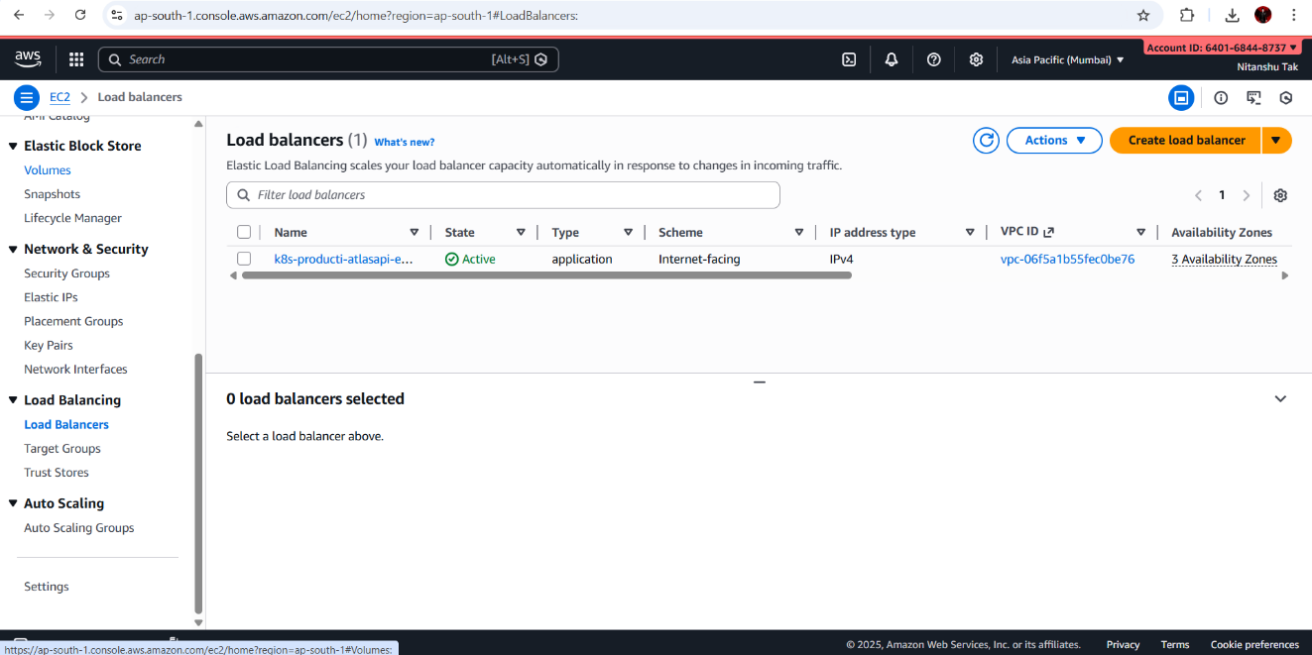

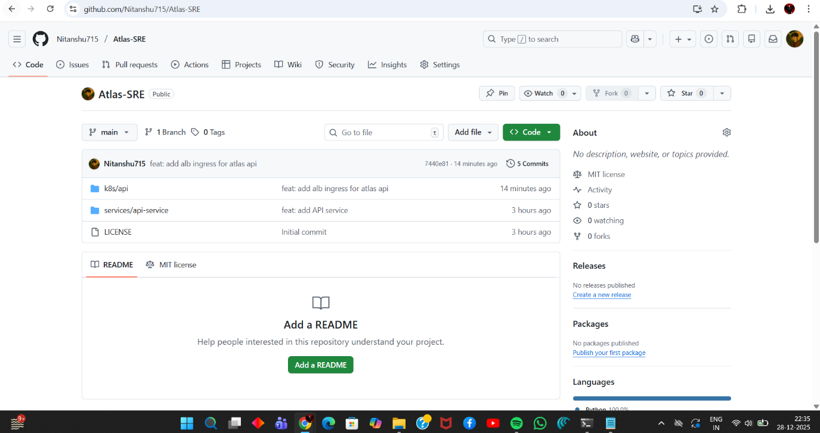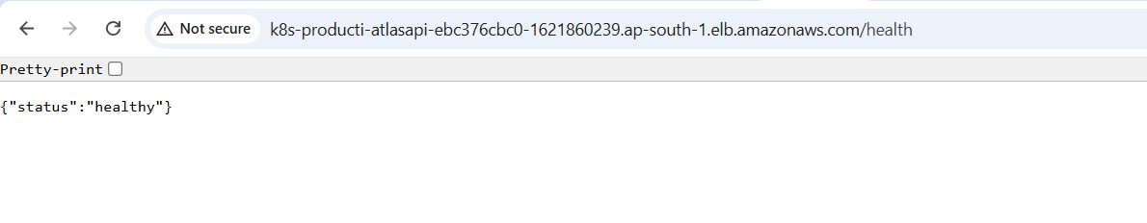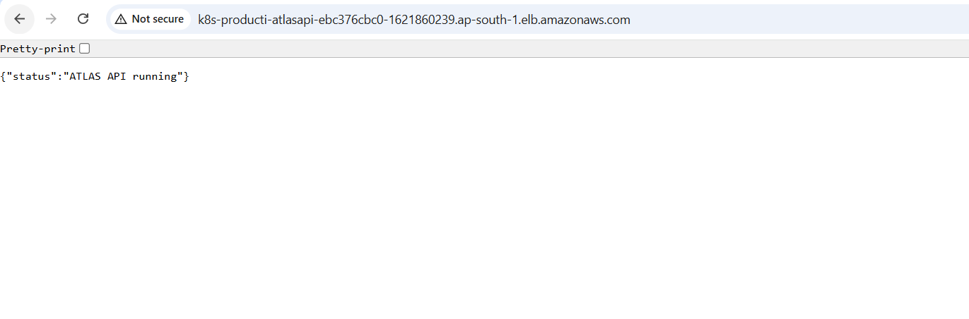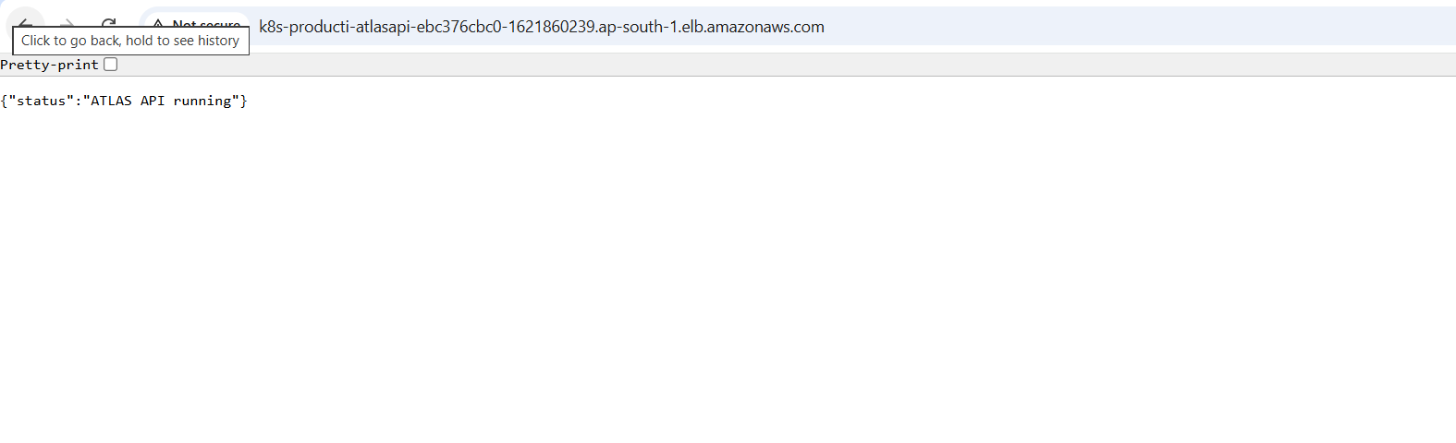

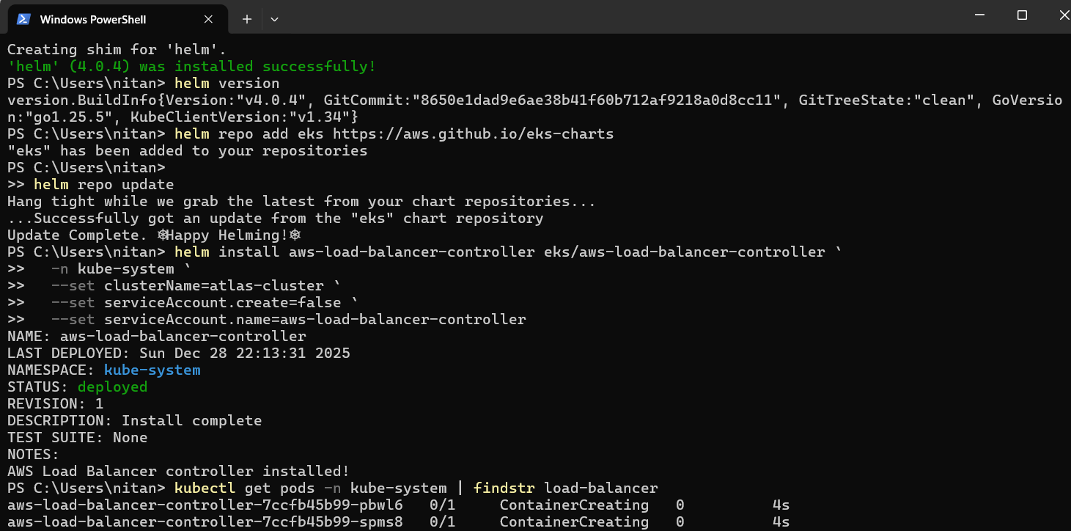

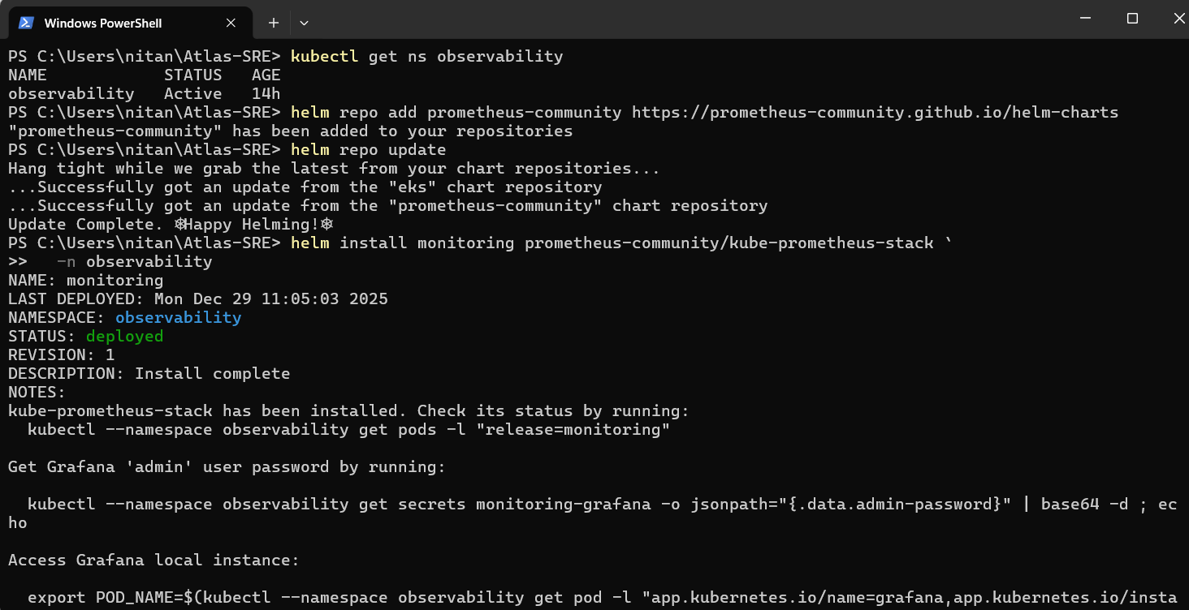

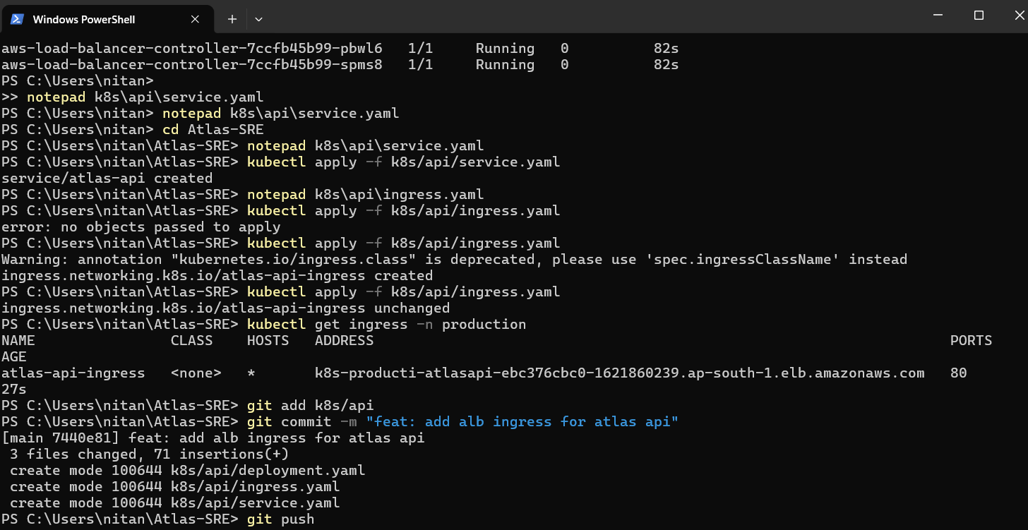

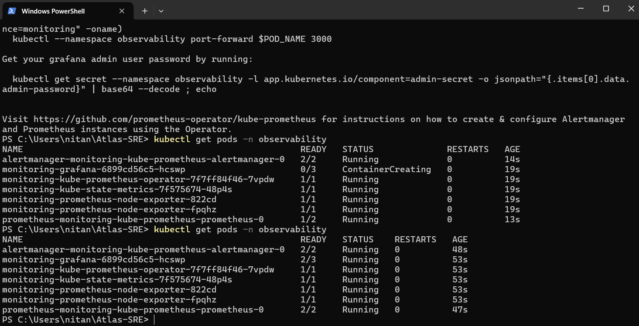

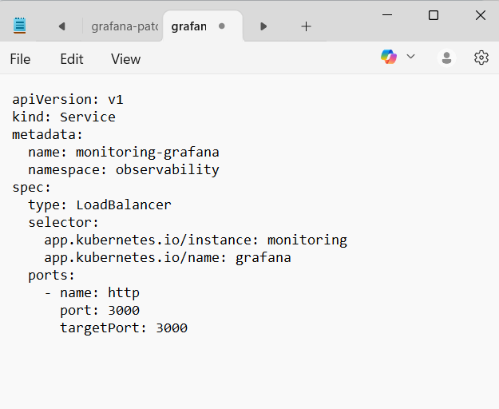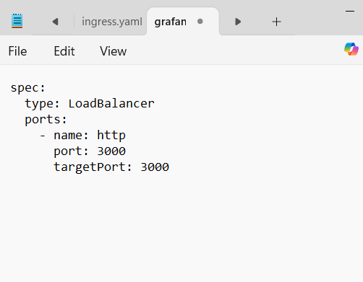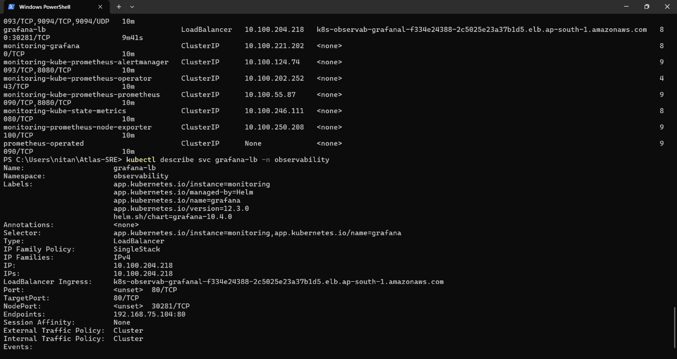

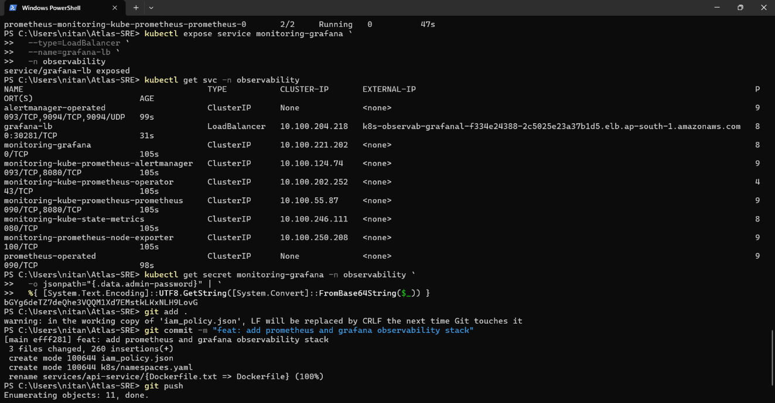

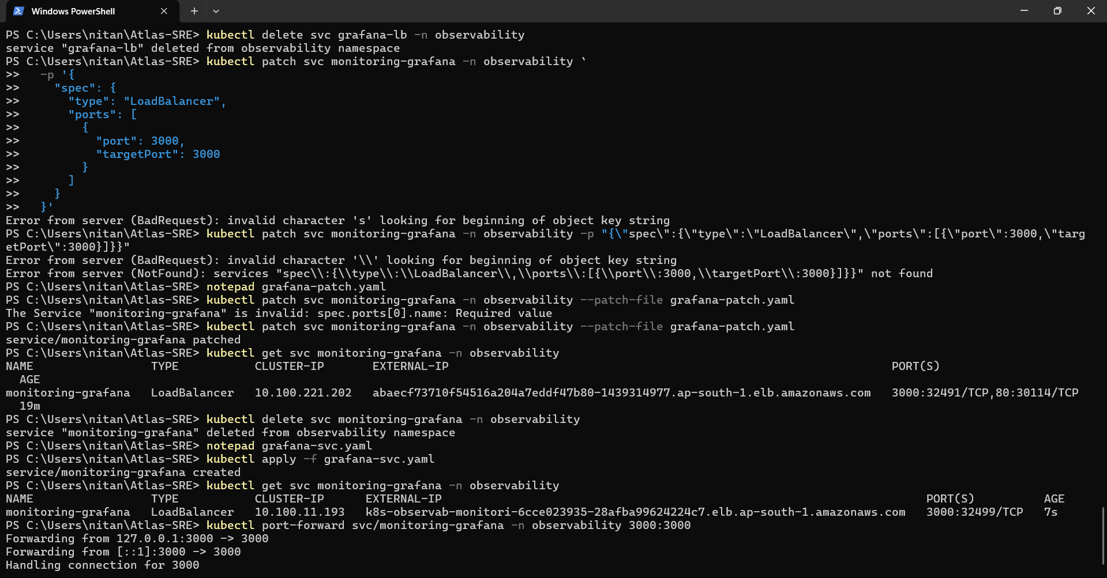

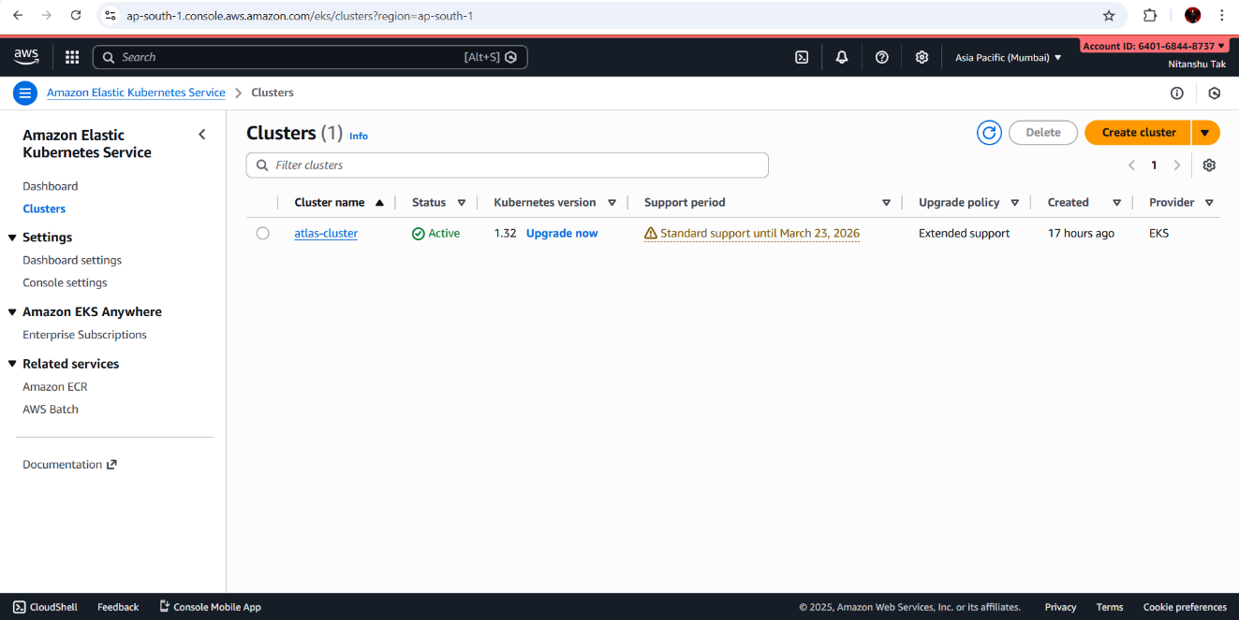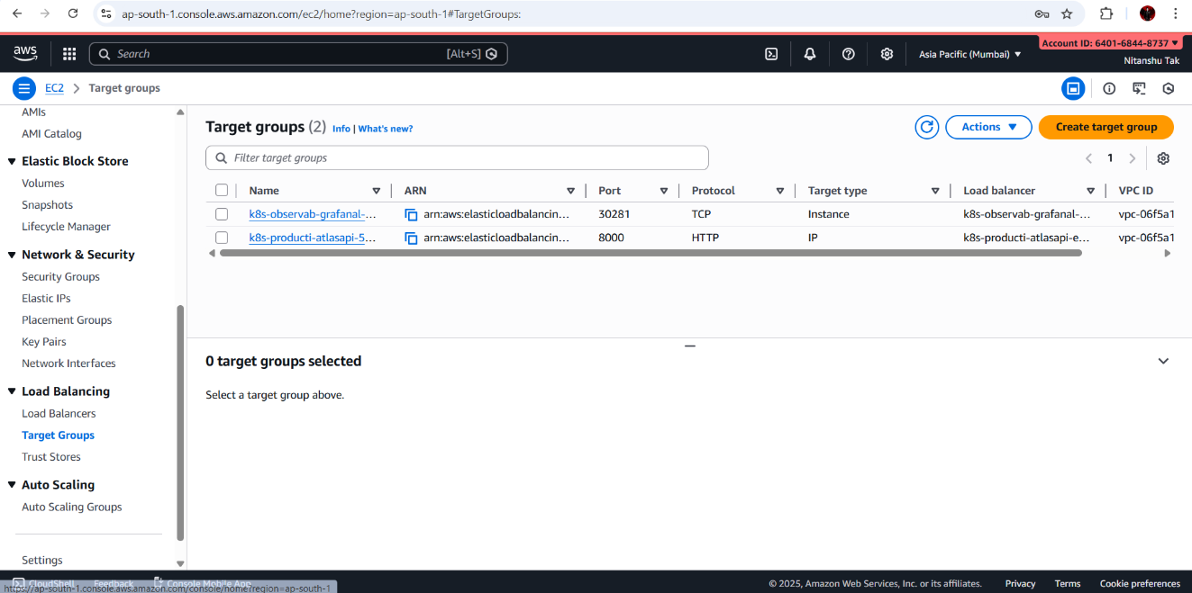

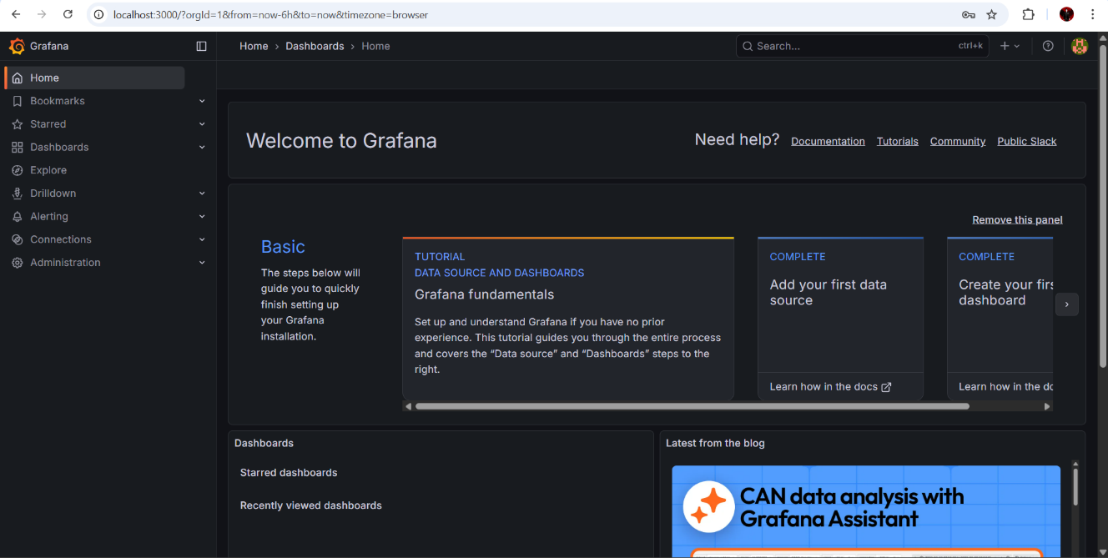

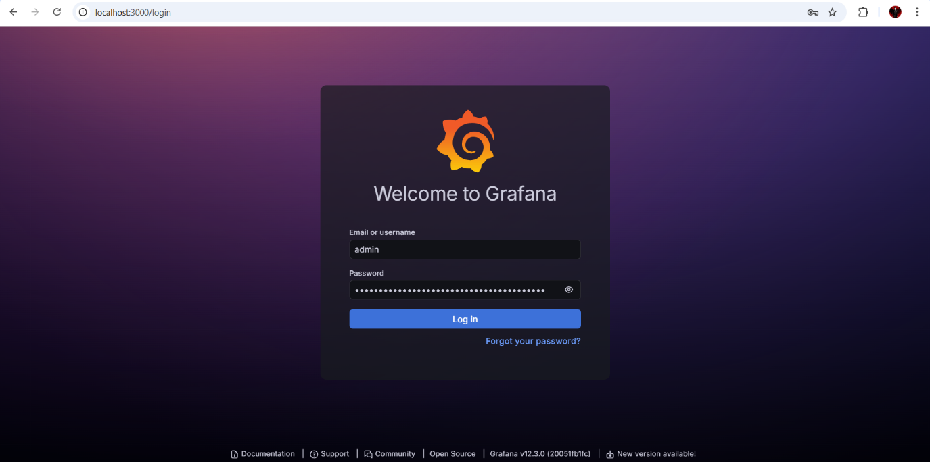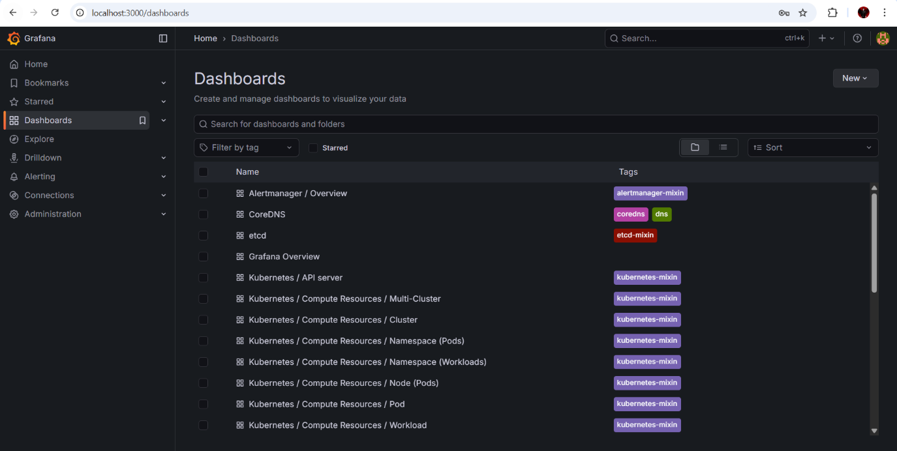

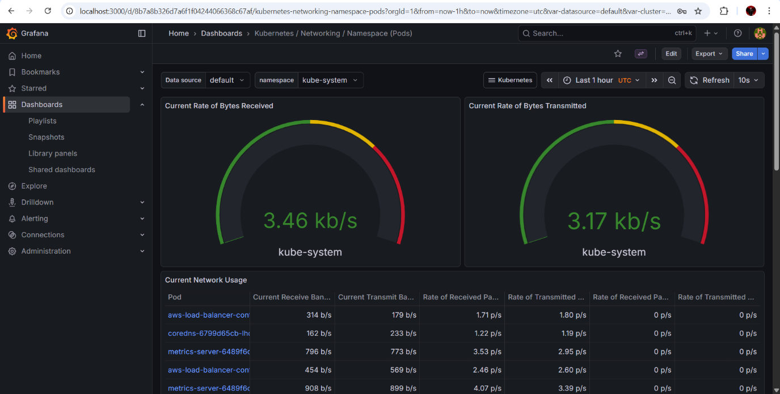

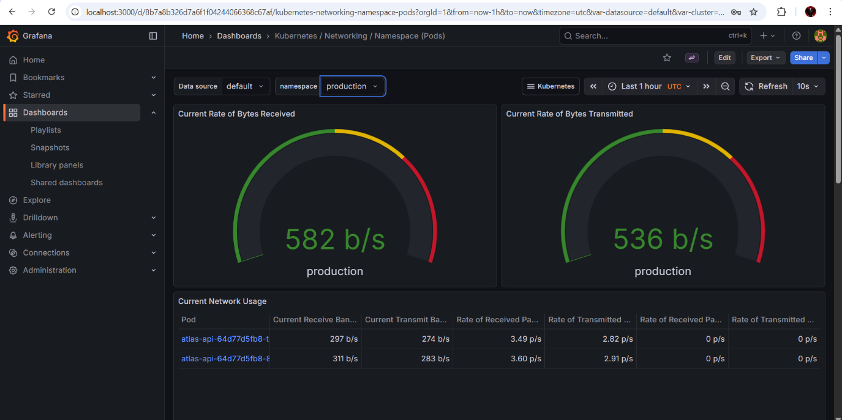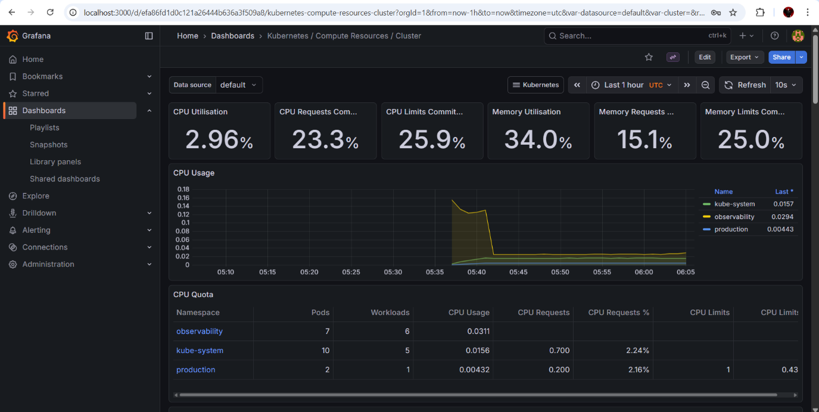

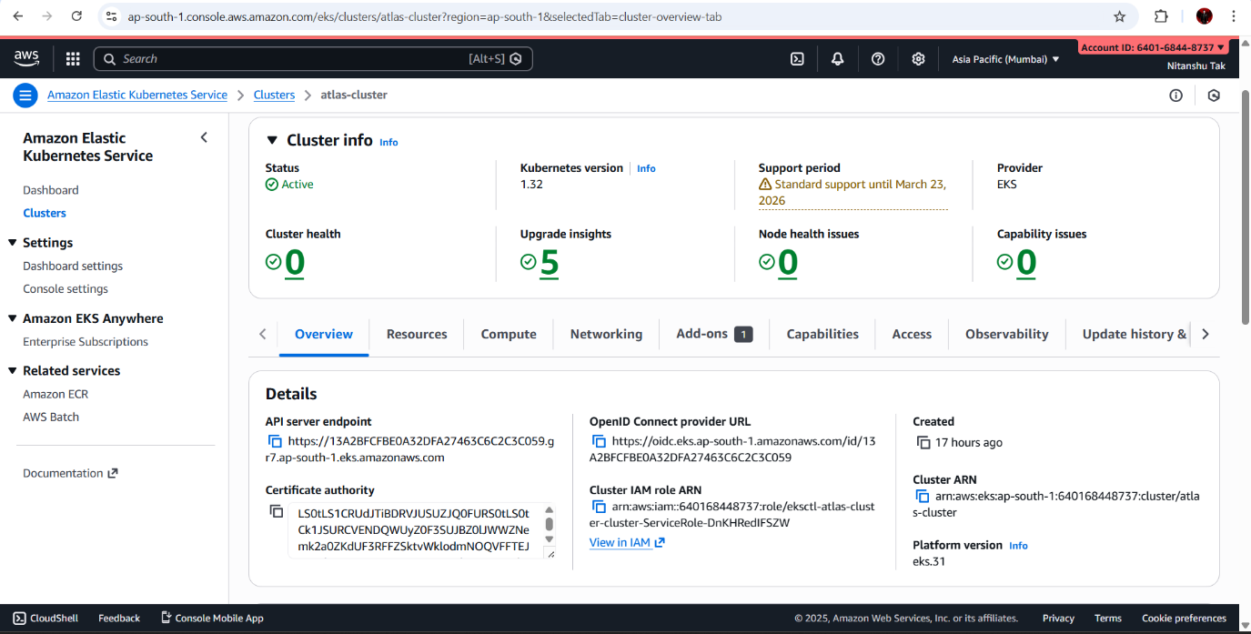

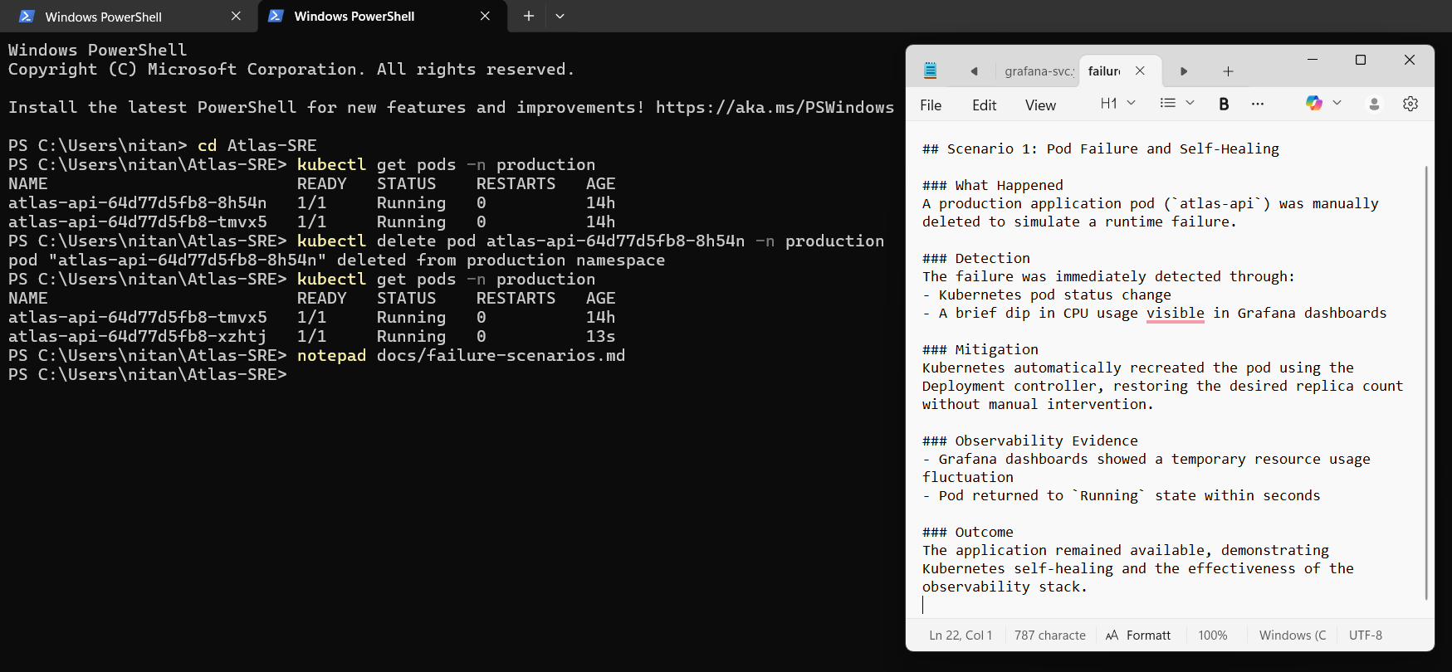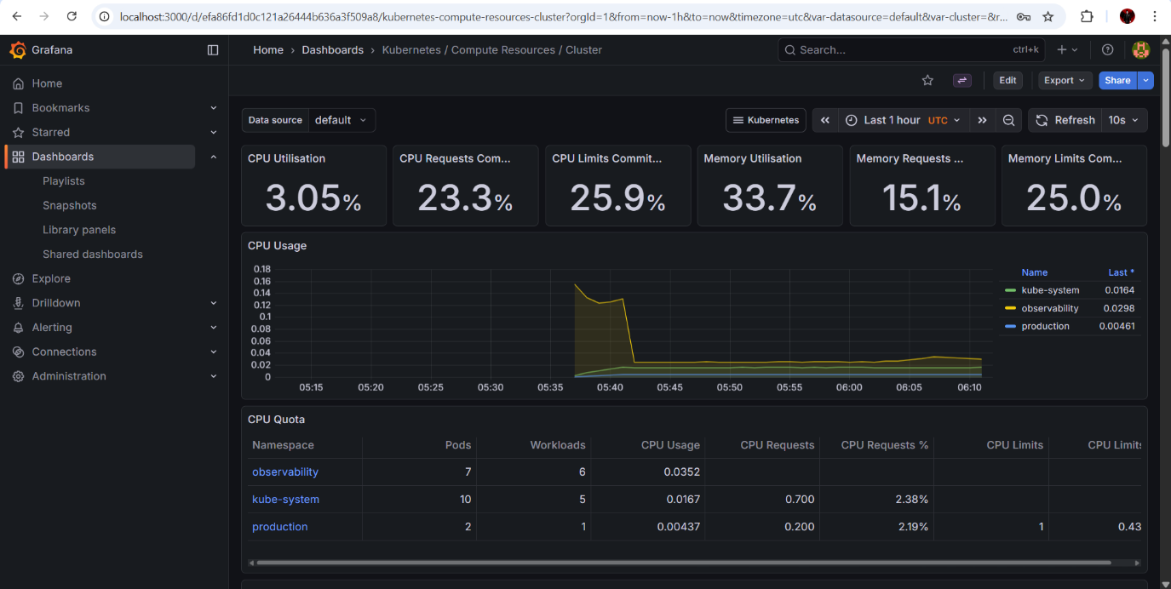

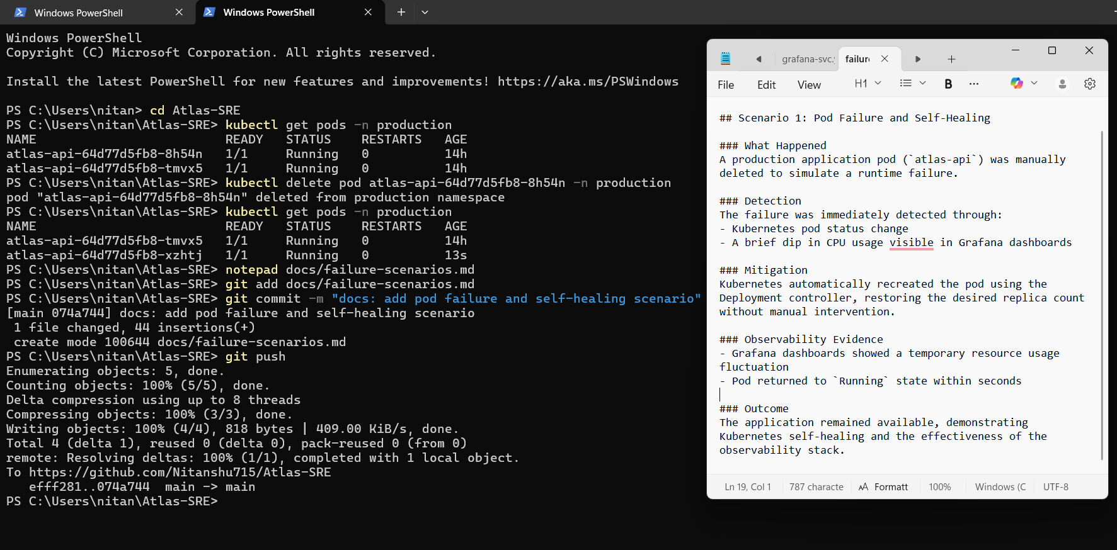

**19. FINAL CONCLUSION**

ATLAS-SRE represents a complete, production-grade DevOps and SRE implementation.

It demonstrates:

• Real infrastructure

• Real failures

• Real recovery

• Real observability

This project reflects how modern cloud systems are actually built, operated, and validated.